坐标系id

1、ESPG

https://epsg.io/transform#s_srs=4326&t_srs=3857&x=NaN&y=NaN

https://epsg.io/4326

2、wkid

https://www.esri.com/arcgis-blog/products/arcgis-pro/mapping/coordinate-systems-difference/

3、arcgis整理的

空间和投影坐标系id列表

https://developers.arcgis.com/javascript/3/jshelp/ref_coordsystems.html

海拔高：A.M.S.L height above mean sea level - Wikipedia == orthometric heigth椭球面到兴趣点的高度。

椭球高，有时称大地高： ellipsoidal，椭球面到兴趣点的高度。

大地水准高或高程：geoid heigth，是从大地水准面沿法线到地球椭球体面的距离

https://www.sciencedirect.com/science/article/pii/S2090447917300084

https://www.researchgate.net/figure/Relationship-between-ellipsoidal-orthometric-and-geoid-heights_fig1_340030816/amp

https://forum.dji.com/forum.php?mod=viewthread&tid=270404&extra=page%3D1&page=1

https://forum.dji.com/thread-270404-1-1.html

dsm高程是椭球高。

# 1、Geoid Height

<https://en.wikipedia.org/wiki/Geoid>

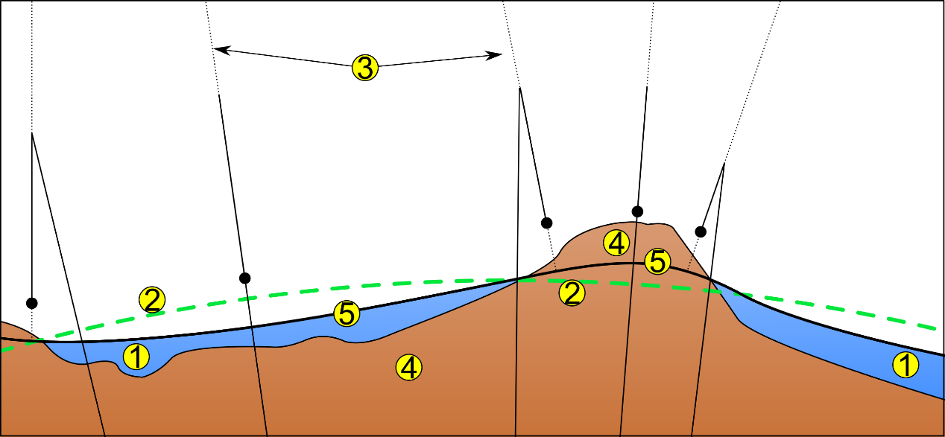

1. Ocean
2. Ellipsoid
3. Local plumb line
4. Continent
5. Geoid

# 2、Orthometric height

<https://en.wikipedia.org/wiki/Orthometric_height>

# 3、Ellipsoid and geoid are references

Ellipsoid and geoid are references. Then you measure the distance between your point of interest and these references. This gives you the orthometric height (AMSL) and the ellipsoidal height (HAE).Geoid height is the difference between geoid and ellipsoid renference. It is this data you will find in so call Geoid rasters. picture source : community.emlid.com

https://forum.dji.com/forum.php?mod=viewthread&tid=270404&extra=page%3D1&page=1

